Derek Dieter  deetro@gmail.com  Height: 5’9” Weight: 175 Hair: Bald Eyes: Blue | 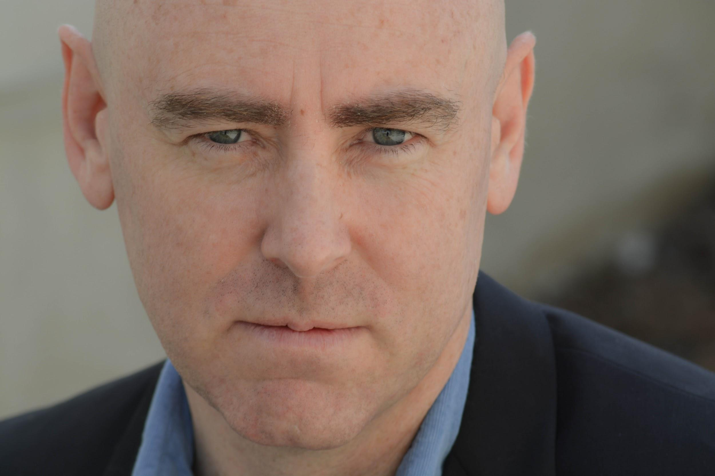

THEATER:
Sketchyprov Improviser Pack Theater, Los Angeles 2019
Fix it in Post Team Improviser Pack Theater, Los Angeles 2018
Self Rattlin’ Snake Improviser Pack Theater, Los Angeles 2018

COMEDY:
2018 How To Be Successful Playing The Sax! (TV Movie) (actor / director)
2017 Those Crazy Librarians! (Short) (actor)
2017 Hawaii Oh Oh! (Short) (actor)
2017 Behind the Mask: Not on Facebook! (Short) (writer, actor)
2017 Can't Date a Girl With The Klimt! (Short) (producer)
2017 Secret Story: Vegan Turns Meateater! (Short) (actor)

TRAINING:
Pack Theater Improv Program Graduate 2018
Character class 2018
Stand Up 2019

